Manuscript Title Written Here, with the First Letter of Each Word Capitalized, Bold, Times New Roman 12pt

The article title in Indonesian is written here, bold and italicized, only the first letter of the title is capitalized, Times New Roman 10pt

Author¹, Author², Author³
¹Author Institution 1 (write only the name of the university, followed by city and country)
²Author Institution 2 (write only the name of the university, followed by city and country)
and so on...
¹Email: Author’s email 1
²Email: Author’s email 2
and so on...

Received …; Accepted …; Published … filled by the editor
Keywords |  | Abstract
Write the keywords in English here, separated by semicolons (;) and ending with a full stop (between 3—5 key words/phrases). |  | Write the English abstract in this section in italics. Abstract should be the same as the final approved manuscript, maximum 200 words. Abstract is written in Times New Roman font size 8pt.  The abstract must contain: research objectives, research methods, and research results.
Kata kunci |  | Abstrak
Write the keywords in Indonesian here, separated by a semicolon (;) and ending with a full stop. |  | Write an abstract in Indonesian in this section. The abstract should be the same as the final approved manuscript, maximum 200 words. The abstract is written in Times New Roman font size 8pt.  1. The part written in this abstract box is written in Times New Roman 8pt.  2. The author's name is written in Times New Roman font size 10pt in bold.  3. Correspondence author data is listed at the bottom of this first page.  4. The author's identity is written in Times New Roman 8pt.  Please do not change the layout of this final template. Red text can be removed.
Copyright © 2024 The Author(s).
Published by HISKI Komisariat Kalimantan Timur.

How to cite this article (using APA 7th edition) filled by the editor
Authors. (2024). Title. Journal of Literature and Education, Volume(Number), first page—last page. https://jurnal.hiskikaltim.org/index.php/jle/article/view/5

A. Introduction

The introduction contains the background of the problem that explains the phenomenon to be researched with the support of recent reference sources (the last ten years) and previous related research results that have been carried out by yourself or others and explain the existence of research in that context (as the state of the art of research). The introduction also contains the problem (preferably only one problem that is the focus of the research), the purpose of the research, and the theory used to solve the problem. All sources referred to or cited must be listed in the bibliography. The introduction does not use subchapter headings. Maximum 20% of the entire body of the manuscript. This section must written in Arial size 10pt single-spaced.

B. Method

The research method contains the methods used in the research and should be described clearly and in detail, including the research steps. Maximum 10% of the entire body of the manuscript (between half to one page, depending on the number of pages of the whole manuscript). The methods section does not need to use subchapter details. The presentation of methods can use a paragraph-paragraph model. This section must written in Arial size 10pt single-spaced.

C. Results and Discussion

The discussion explains the research results in accordance with the issues raised in the research. It can comprise a maximum of 65% of the entire body of the manuscript. The DISCUSSION section does not need to be separated between RESULTS and DISCUSSION.
If there is numbering in the content section, please follow the following numbering, and the subchapter titles are bolded.
1. ……
a. ……
(1) ……
(a) ……

Tables and Figures are written according to the example, with numbering in the order in which they appear. Table titles are left-aligned, bold, Arial 10pt. Table contents are written in Arial 8pt. The title of the figure is written center-aligned, bold, Arial 10pt. If the table is taken from a source, place the source at the bottom of the table, left-aligned, Arial font size 10pt, italicized. If the figure is taken from a source, set the source at the bottom of the figure title, center-aligned, Arial 10pt font, bold. Each table and figure/graphic in the manuscript must be explained or called a paragraph.

Table 1. The table is written according to this example
No. | Level of Agreement | Weighted Value
1 | Strongly agree | 5
2 | Agree | 4
3 | Undecided | 3
4 | Disagree | 2
5 | Strongly disagree | 1
Source: … (if any)
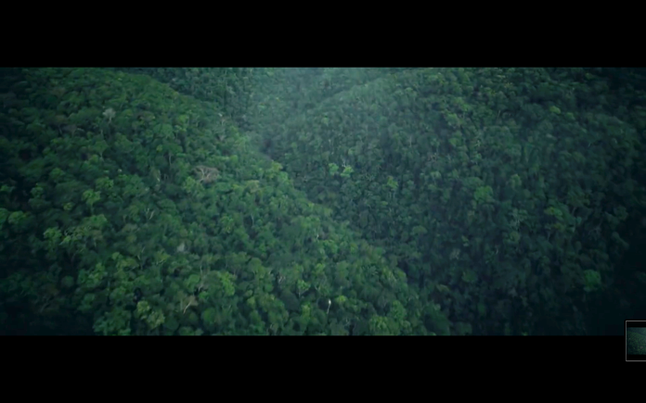

Picture 1. The Image Written According to This Example
(Source: … if any)

D. Conclusion

The closing contains conclusions that answer the problems and research objectives expressed in the Introduction (suggestions and recommendations can be added - not required). The closing section is a maximum of 5% of the entire body of the manuscript. This section must written in Arial size 10pt single-spaced.

E. Acknowledgements

This section is optional/not mandatory, containing information related to the acknowledgment of those who have assisted in the preparation of the article or the implementation of the research financially/research funding assistance. This section must written in Arial size 10pt single-spaced.

References

Write the REFERENCES of the article in this section, according to the final article that has been approved by the editor. THE REFERENCE TO THE LITERATURE MUST BE WRITTEN IN ACCORDANCE WITH THE FOLLOWING PROVISIONS!
- MINIMUM literature sources come from 20 sources with 80% being primary sources and come from research results, ideas, theories or concepts that have been published in journals, both printed and electronic versions. The references referred to are the results of publications in the last 10 years, except for classic references used as historical studies.
- The writing of the bibliography MUST follow the provisions of the APA 7th edition with single spacing and MUST use the Mendeley application.
- All sources cited in the body of the manuscript MUST appear in the REFERENCES. Conversely, sources in the REFERENCES must be cited in the body of the manuscript.
- You MUST cite at least 2 articles published in JLE journals.

Corresponding author: write down the author's name, email, and correspondence WA number (example: Eko Widodo, Email: ekowidodo@gmail.com, Phone: +628123456789)

